RITA GT

WE SHALL OVERCOME!
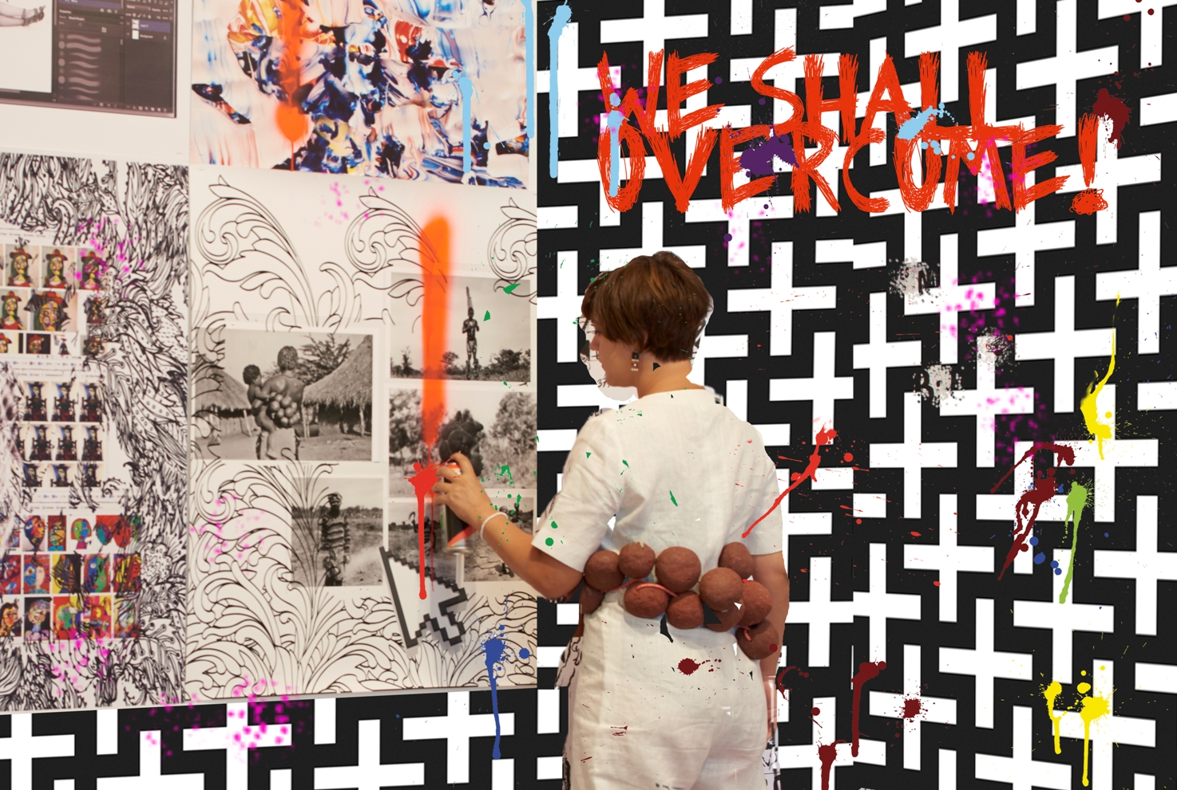
We shall overcome!, 2015. Photo Sylvain Deleu intervened by Rita GT

05.12.15 – 10.01.16

OPENING · DECEMBER 4 – 7 pm

WE SHALL OVERCOME!

We Shall Overcome! is an internationally recognised message originated from the late-nineteenth century gospel hymn ‘I Will Overcome Someday’. In 1948, the hymn was adapted by the North American folk singer Pete Seeger, who published the protest song ‘We Will Overcome’. This song became widely known, and in the 1960s, it became the anthem of the civil rights movement in North America. The slogan was used during different moments of protest, including Selma to Montgomery marches; in South Africa during the anti-apartheid struggle; spoken by Martin Luther King in his last speech before being assassinated; adapted to the Czech language during the Velvet Revolution in Prague and even adopted in India in countless situations.

Rita GT has appropriated the title of this historic song – the anthem of the struggle for freedom of expression, for equal social and racial rights, of pro-democracy movements throughout the world – in order to give it a new spatial and temporal dimension. Her work reflects the present sense of discontent and injustice, of the duping of democracy by subversive tyrannies that undermine and dominate the intricacies of society, politics and economy. The artist explores the questions that generate social tension not only in Angola, where she lives since 2012, but also in the

rest of the world, such as mass illegal migration, human trafficking, terrorism and mass deaths.

The project presented by Rita GT at MNAC will come out from a performance that will take place during the opening day and will be recorded on a video that will be available in the exhibition space and online from the next day. On that day, a group of people, wearing overalls made of patterned African fabric, designed by the artist, will enter the museum carrying brooms and buckets to cover the wall with a wallpaper also designed by the artist. During this process, there will be the participation of the Nigerian musician Keziah Jones and a group of dancers. The artist will take part in hanging the wallpaper and, using spray paint, will draw signs linked to the concept of the slogan that echoes around MNAC.

Thus, various aspects of the use of these words of struggle and protest are evoked in a multidisciplinary action: music and the power of words; the link established by the African fabric with black and women’s rights; the act of marching and the principle of peaceful protest; the power of the group; the importance of artistic interpretation and of what should be perpetuated.

Curator
Adelaide Ginga

RITA GT
Born in Porto, in 1980.
Lives and works in between Luanda, Angola and Viana do Castelo, Portugal.
BA in Communication Design (2004) from the Faculty of Fine Arts, University of Porto. Erasmus held in Sofia's Fine Arts Academy, Bulgaria. Advanced Course in Visual Arts, Maumaus - School of Visual Arts, Lisbon and attended the master's degree at Malmö Art Academy - Lund University in Malmö, Sweden.
She’s the founder and manager of the e.studio Luanda project and curated the most recent solo exhibitions of the Angolan artists, Antonio Ole in Madrid and Van in Luanda.
She was the commissioner of Angola official representation at the 56. Biennale di Venezia.
Rita Gt held solo exhibitions: A.I.R – African Industrial Revolution, Revolution Will Be Downloadable (com Porjecto e-studio Luanda), Tiwani Gallery, London (2015); Faces (Caras não Caras) at Instituto Camões, Luanda (2014); AIR - African Industrial Revolution at UNAP, Luanda (2012); Looting (2010), Museum of Costume, Bienal de Viana do Castelo; One Night [life] Event (2009), Empty Cube, Lisbon; Made in Europe, 10 Year Warranty (2009), Gallery

Reflexus Porto; Tropicalismos Luso e outras Naturezas Mortas (2007), PêSSEGOpráSEMANA, Porto. She participated in several group exhibitions, namely: Mabaxa (2012), Soso Gallery - Contemporary African Art, Luanda; The Philosophy of Money (2011), Museum of the City; Amália Nossa (2009/2010), CCB – Museu Berardo, Lisbon; Options & Futures: Collection of PLMJ Foundation (2007), ArteContempo, Lisbon; Anteciparte (2007), Natural History Museum, Lisbon; and Rothschild Prize (2007), Lisbon. Was in residency at Casino Luxembourg (2005), in Luxembourg; ZDB (2007/08) and under the INOV-Art program at the artist residency Capacete, Rio de Janeiro and São Paulo.

Main Sponsors
